VAISHNAVI E 231901059

**EX.NO:2A DATE:**

# SHELL SCRIPT

**AIM:** To write a Shell script to display basic calculator.

**PROGRAM:**

echo "Enter number1" read a

echo "Enter operator"

read op echo "Enter number2" read b

c=$(echo "$a $op $b" | bc-1) echo

"Result: $c"

**INPUT & OUTPUT:**

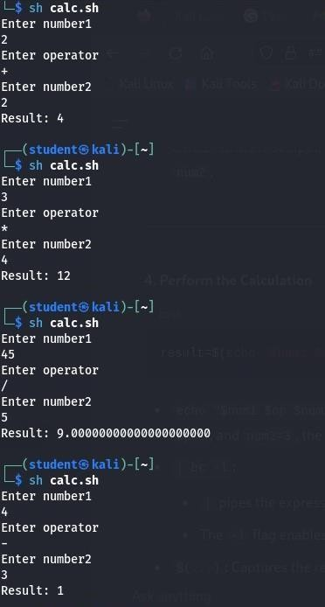

**RESULT:** Hence, simple calculator using shell script is executed successfully.

**CSE-CYBER SECURITY**